# Objective

To fluent with fundamental Processing commands and coordinate system so that these methods become second nature.

## Topics: method calling, coordinate system

# Instructions

Using your foundational knowledge of Processing, draw a smiley face on a window that is 800 x 600. You may choose the colors and sizes of the smiley face you draw. It should include two eyes, one nose and a mouth. Save the sketch as “*LastNameFirstName_Smiley*”

# Examples

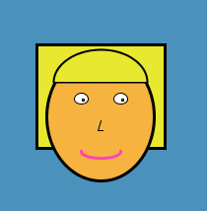

# Hints

Sometimes Processing does not have the exact shape we need. Use combinations of shapes that overlap to get the effect you need. For example, the following code:

**fill(**0**)**;  
**ellipse(**200,250,200,200**)**;  
**noStroke()**;  
**fill(**255**)**;  
**ellipse(**200,200,200,200**)**;



Will draw a black circle then a white circle on top to give the appearance of a smile:

# Challenge

Use the technique from the Hint section to add shading to your Smiley Face and give it a more three dimensional look.